**Transparent Conducting Oxides:**

Electrically conductive materials called transparent conducting oxides (TCOs) have a similarly low level of light absorption. They are frequently made using thin-film processes and employed in opto-electrical devices such solar cells, displays, opto-electrical interfaces, and circuitry. While silicon and compound semiconductors are wavelength dependent optical resistors (producing mobile electrons), they are dopant dependent electrical conductors. Glass fibers are essentially lossless light conductors but electrical insulators. Both of these qualities can be found in transparent conducting oxides, a very flexible intermediate state. They can have conductivities that range from insulating to semiconducting to conducting, and their transparency can be altered. Numerous power-saving opto-electrical circuitries and technological applications are made possible by their ability to be created as n-type and p-type conductors [30].

Transparent conducting oxides (TCOs), which are an essential component in practically all thin-film photovoltaic devices due to their dual properties of optical transparency and electrical conductivity. TCOs typically rely on a small class of metal oxide semiconductors, such as In2O3, ZnO, and SnO2, which are transparent because of their wide band gaps and can withstand extremely high levels of electrical doping to provide conductivities of at least 1000 S/cm [31]. TCOs are made up of a class of substances known as "conjugate property materials," in which one characteristic—in this case, conductivity—is closely correlated with another, notably the extinction coefficient [32].

In this sense, it may be said that highly conductive materials like metals won't typically transmit visible light, whilst extremely transparent media like oxide glasses act as insulators. Understanding the fundamental material structure/property relationships that control these properties is difficult to do in order to decouple them and produce materials that are optically transparent while also being electrically conductive. There have been reports of materials being created with these qualities using a variety of phenomenological methodologies based on clear-cut physical principles.

By fundamentally comprehending the microscopic basis of the conductivity process in order to grasp the impact of chemical structure, bonding, and film shape on charge transport, more recent research push the boundaries of the earlier work. A transparent electrode with TCO is necessary for the majority of optoelectronic devices, notably those with flat panel displays. Although most transparent electrode applications have used tin-doped indium oxide (often known as indium-tin oxide, or ITO) thin films produced using magnetron sputtering, there are several reports on various TCO's as well as deposition techniques [33]. Because indium, the primary component of ITO, is expensive and in short supply, it may be challenging to maintain a steady supply of ITO for the rapidly developing market for optoelectronic devices. Thin-film transparent electrodes with unique features are further needed due to current advancements in optoelectronic devices. These issues are the major focus of recent research on materials and manufacturing processes for TCOs. For instance, several research teams across the globe are focusing on the modification of zinc oxide (ZnO) as a less expensive alternative to ITO [34].

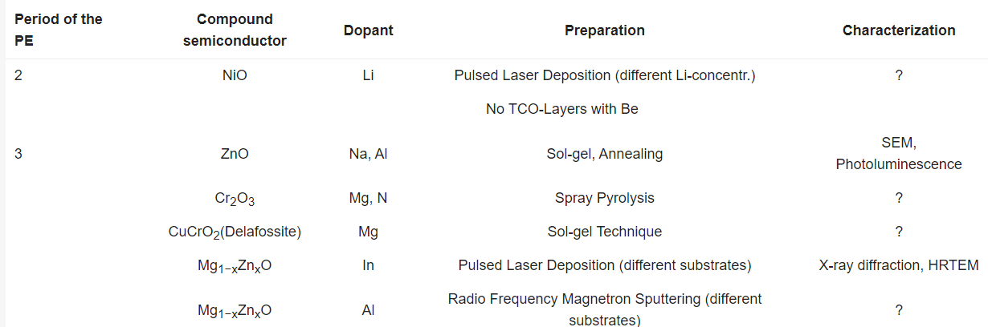

**Table 1.**Published results regarding transparent conducting oxide (TCO)-layers, containing metallic elements e.g., from the 2nd and 3rd period of the periodic table of the elements (PE, excluding aluminum) [30].

The oxides of tin, indium, and zinc (A = tin, indium, and zinc) exhibit exceptionally high optical properties. Indium tin oxide (ITO) and the doping of zinc oxide with less than 5% aluminum (ZnO:Al) are two examples of materials that are well recognized. Their various chemical structures and physical traits were investigated using a range of preparation and characterization techniques. We'll speak briefly about these now [30].

**Properties of TCO:**

TCOs are distinctive materials with optical transparency (band gaps > 3.1 eV) and electrical conductivity (carrier concentration of at least 1019cm-3). Visible light photons are prevented from excitably transferring electrons from the valence band (VB) to the conduction band (CB) by a band gap greater than 3.1 eV. By introducing defects—either inherent or extrinsic—into the system, these transparent materials are subsequently turned electrically conductive. Depending on the imperfections and the material's type of conduction, TCOs can be categorized as n-type or p-type.

In the case of p-type conduction, these defects generate split off acceptor (unoccupied) levels above the valence band maximum (VBM) and donor (occupied) levels below the conduction band minimum (CBM). ZnO based TCO films have been created using a variety of techniques, each of which has advantages and disadvantages of its own.

The thickness, substrate, growth temperature, dopant, and their composition will all have a significant impact on the structural, electrical, and optical characteristics of the films, even if they are made using the same process. The future of ZnO based TCO films will thus depend on our ability to optimize the manufacture of high-quality doped zinc oxide thin films at a reasonable price.

**n-type TCO:**

N-type semiconductors made of metal oxides have been the subject of the majority of research into the development of extremely transparent and conductive thin films. Historically, chemical and physical deposition techniques were used to create transparent conducting oxide (TCO) thin films made of binary compounds like SnO2 and In2O3. Indium tin oxide, or ITO, and impurity-doped SnO2 (Sb- or F-doped SnO2, for example, SnO2:Sb or SnO2:F) films are now in use. Prior to 1980, ternary compounds including Cd2SnO4, CdSnO3, and CdIn2O4 were also produced, but their TCO films have not yet been extensively employed. Other TCO materials have been developed as alternatives in order to achieve lower resistivities than those of TCO films such ITO and SnO2 doped with impurities. Impurity-doped ZnO, a cheap and plentiful binary compound material, was created in the 1980s.

To create transparent conducting films with resistivities lower than ITO and with qualities suited for particular applications, new n-type TCO material development is required. Despite the fact that new TCO materials have not yet been reported to exhibit resistivities lower than in ITO films, multicomponent oxides that have recently been produced as TCO materials are suited for particular applications. By modifying the chemical composition, it is possible to change the electrical, optical, chemical, and physical characteristics of transparent conducting multicomponent oxide films, including bandgap energy and work function [35].

**p-type TCO:**

Transparent conducting oxides are a special family of materials that combine optical transparency with electrical conductivity in a single substance. They are required for a variety of products, including transparent electronics, flat panel displays, touch screens, light emitting diodes, solar cells, and flat panel displays. The majority of TCOs used in industry are n-type materials, such Sn-doped In2O3, Al-doped ZnO, and F-doped SnO2. The creation of effective p-type TCOs, however, continues to be a significant obstacle. The difficulty in adding shallow acceptors and large hole effective masses is assumed to be caused by the confined character of the O 2p derived valence band. To solve this issue, Hosono and colleagues (1997 Nature 389 939) suggested the idea of 'chemical manipulation of the valence band' by hybridizing O 2p orbitals with close-shell Cu 3d10 orbitals. With a thorough grasp of the underlying materials physics, this discovery has spurred a great deal of interest in creating p-TCO materials [36].

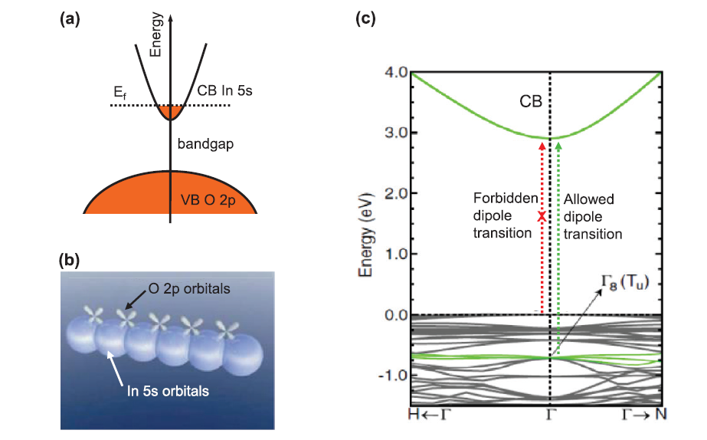

**Figure:** (a) In2O3 doped with Sn, with a schematic electrical structure illustrating the conduction band (CB) produced from In 5s and the valence band (VB) derived from O 2p; (b) In2O3 schematic orbital diagrams; Large spheres represent In 5s orbitals, displaying direct overlap between nearby s orbitals; oxygen 2p orbitals contribute little to the picture. (c) Density functional theory (DFT) calculated band structure of In2O3 [36].

**Electrical conductivity:**

Due to doping by oxygen vacancies or extrinsic dopants, TCOs are wide band gap (Eg) semiconducting oxides with conductivities in the range of 102 to 1.2106 (S). These oxides transform into extraordinarily effective insulators without doping, with resistivity > 1010 Ohm-cm. N-type semiconductors make up the majority of TCOs. The density and mobility of the electrons in the conduction band determine the electrical conductivity of n-type TCO thin films. Numerous population processes and models explaining electron mobility were developed to explain the TCO properties. Electronic structural investigations have revealed connections between a few mobility traits and the methods used to fill the conduction band with electrons [37].

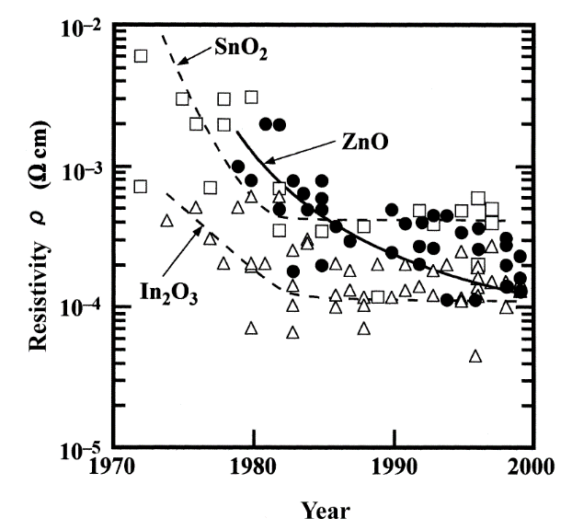For instance, the mobility is inversely proportional to the band gap size. The conductivity of these TCOs can be increased by further doping elements with additional charge carriers. Higher doping concentration substantially decreases carrier mobility, preventing a rise in conductivity. Additionally, it reduces optical transmission at the edge of the near infrared spectrum. The resistivity approaches a lower limit with a rise in dopant concentration, beyond which it cannot drop. However, the optical window gets smaller.

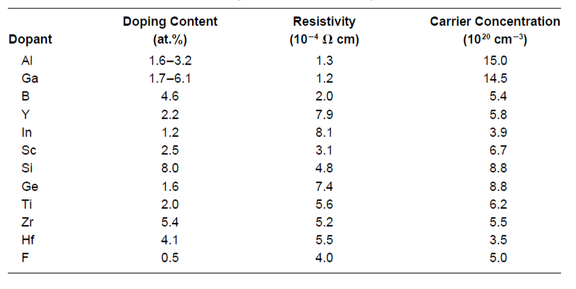

**Figure:** Reported (1970–2000) resistivities of binary transparent conducting oxide (TCO)

materials: undoped and impurity-doped SnO2(▯), In2O3 (△), and ZnO (**●**) [35].

**Table:** Resistivities, Carrier Concentrations, and Dopant Content for ZnO Films Doped with Various Impurities [35].

**Optical Properties:**

As was already noted, excellent TCO thin films should also have a very low absorption coefficient in the vicinity of UV, VIS, and NIR. Eg controls transmission in the near-UV area because photons with energies greater than Eg are absorbed. There aren't any "ideal" TCO thin films, and even if there were, interference and reflection would impede with the transmission. Therefore, achieving complete transparency over a large area is impossible.

The basic band gap of TCOs is rather big, which is a prerequisite for excellent transparency. However, highly n-type doped TCOs have a carrier concentration that may exceed 1021 cm3. The threshold of the transition may happen k points away from the zone center due to the Moss-Burstein effect. Additionally, in highly doped systems, a transition between the conduction bands is possible. The optical transitions between the occupied conduction states and the other conduction band states, as well as those between the valence bands and the unoccupied conduction band states, influence the optical properties of TCOs [38].

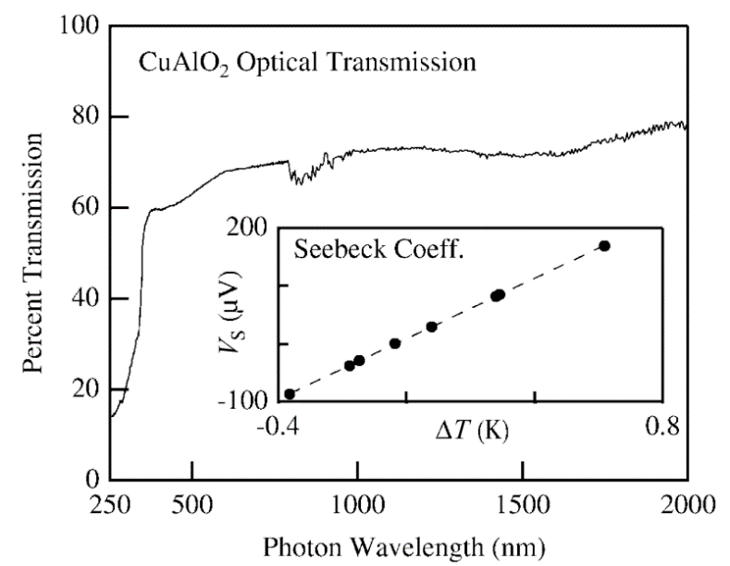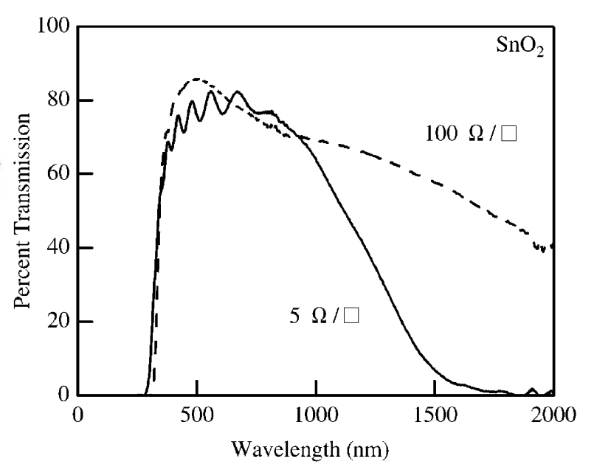

**Figure.** Optical transparency and Seeback data for a 300–500-nm-thick film of p-type CuAlO2 [39].

**Figure.** Optical transparency versus conductivity for two SnO2 films. As the resistivity decreases, long-wavelength transparency also decreases [39].

**Work function:**

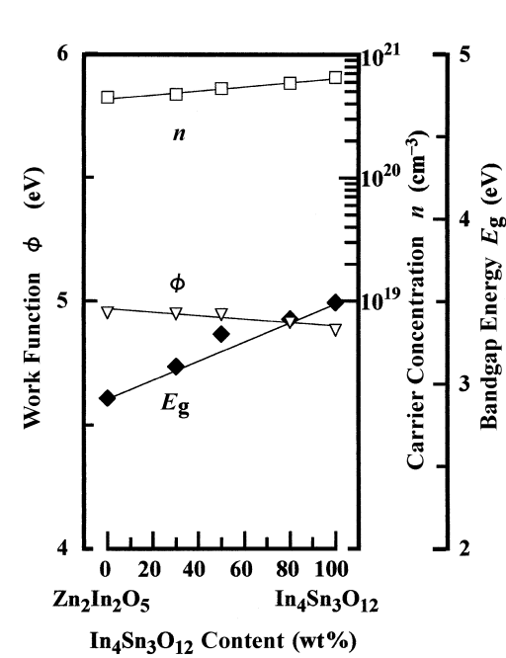The work function (f), which is the minimal amount of energy required to remove an electron from a metal, is determined by the energy difference between the Fermi energy level and vacuum level. The work function and ionization energy of metals are same. The work function can be significantly impacted by the surface's condition. The work function can be significantly altered by the presence of very small amounts of contamination (less than a monolayer of atoms or molecules) or by the occurrence of surface processes (oxidation, for example). Depending on the surface quality, changes of the order of 1 eV are typical for metals and semiconductors. These modifications are brought about by the development of electric dipoles at the surface, which alter the energy required for an electron to depart the sample. The work function is sensitive to chemical surface changes, hence measuring it can provide important information on the state of a specific surface [40]. The Fermi level is found within the band gap of a nondegenerate semiconductor, which has a moderate doping level. The energy difference between the valence bands maximum (VBM) and vacuum level (ionization energy) and work function are now different. Since there are no permitted electronic states within the band gap in a semiconductor, the Fermi level becomes more or less a theoretical parameter. This means that the Fermi distribution, a statistical function that estimates the likelihood of finding an electron in a particular electronic state, must be taken into account. The Fermi level is the region of the energy spectrum where probability is only 50%. Untreated AZO and ITO typically have work functions of 4.97 and 4.7 eV, respectively [41], whereas plasma cleaning of the TCO in O2 typically results in an increase in work function of between 0.1 and 0.3 eV.

**Figure.** Carrier concentration (▯), bandgap energy (◆), and work function ( ▽ ) as functions of In4Sn3O12 content for Zn2In2O5-In4Sn3O12 films prepared by rf MSD [35].

**Thermal and Chemical stability:**

The thermal stability temperature is the point at which the characteristics of TCO coatings noticeably alter or deteriorate. ZnO, SnO2, and Cd2SnO4 have reported thermal stability temperatures of 250°C, 500°C, and 700°C, respectively [13]. Above this temperature, the films undergo chemical decompositions that lower their quality. Temperature sensitivity of several commercial substrates (glass 500°C, polymer 200°C) limits the processing temperature. Additionally, observations of the TCO films' chemical interactions with the substrate and succeeding layers have been documented in the literature [43].

From an application standpoint, the created TCOs must have thermal stability because they may be subjected to a variety of harsh conditions. The ability of a TCO to withstand corrosive conditions and treatment determines the TCO's chemical stability. TCO sensitivity to decreasing atmospheres is a significant issue for applications like amorphous Si solar cells. When ITO is exposed to hydrogen conditions, it goes through a substantial decrease. In contrast, doped ZnO films are significantly more stable in plasmas and reducing atmospheres that contain hydrogen species [42]. As a result, ZnO-based TCOs might be chosen for applications involving the processing of hydrogen plasma. In contrast, ITO has more stability than other TCOs in oxidizing atmospheres, particularly at high temperatures.

**ZnO as TCOs:**

Zinc oxide has a wide range of uses as transparent conductive oxide (TCO) layers in many optoelectronic applications, including solar cells, optical detectors, biosensors, photoinduced nonlinear optical materials, and others. This is due to its special properties, including a wide band gap of about 3.37 eV and a hexagonal crystal structure.

Recent research centered on techniques that improved electron transport across the flaws and inherent faults in the crystal structure of zinc oxide. The optoelectronic properties of the thin films can significantly alter as a result of optimizing these circumstances. The density of crystal defects (such as Oi, VZn, Zni, OZn, and VO) is altered by adding the dopants from group "III" of the periodic table (B, Al, Ga, and In) and substituting each of them for the Zn atoms. This forms the 3+ ions of donor impurity that can provide an extra electron. Therefore, altering electron traps can greatly improve carrier movement inside the crystal structure. Al impurity among the group III elements has been utilized as a dopant significantly more frequently than the others due to its abundance and stability.

The AZO thin films have been created using several physical and chemical methods. However, the Sol gel process, followed by spin coating, does not require any complicated high vacuum apparatus and is typically used to prepare AZO thin films at ambient temperature.

Due of the wide range of applications for AZO layers, there are several articles about the precursor to its synthesis and the thin film technique, most of which concentrate on the Al atomic percentage. However, it has never been mentioned before how the host substance (zinc oxide) might absorb the contaminant (aluminum). In truth, there is still no answer to the question of what the intrinsic zinc oxide layer's (the host material) suitable structure is for tolerating the ideal amount of impurity [44].

A transparent conductive oxide (TCO) can serve as a solar cell's top electrode. The resistivity should be as low as feasible, while the carrier concentration is decreased to avoid undesirable free carrier absorption in the infra-red spectrum, for a TCO to be effective as an electrode (front and back). Using pulsed laser deposition, Ga-doped ZnO is formed on quartz substrates, however the mobility of the carriers must be as high as possible to boost the TCO's conductivity while maintaining a low absorption coefficient [45].

For a sample placed at 300°C, a resistivity of 8.12 105 cm and a visual transmittance of more than 90% were found. The study of the ZnO/Ag composite thin film structure revealed a considerable reduction in resistivity value with great transparency [46]. The team created sandwich-type ZnO/Ag thin film/ZnO multilayer structures, as those in scheme Figure 2.5.



**Figure 2.5:** Schematics of (a) ZnO/ Ag film/ZnO structure with an Ag thin film layer between two transparent ZnO layers. (b) ZnO/Ag grid/ZnO structure in which the Ag grid is inserted. (c) ZnO/AgNW/ZnO structure in which an Ag nanowire network is present instead of an Ag thin film. Reproduced from ref. [46].

The insertion of an ultrathin silver film with the lowest resistivity (1.6*10-6 Ω-cm) can dramatically lower the sheet resistance, while the thin film at the nanometer scale can transmit visible light.